**21CSS101J – PROGRAMMING FOR PROBLEM SOLVING**

**(Problem Statement and**

**Refute Test Case Submission)**

**Problems in C**

**Name: Nikhil Balamurugan**

**Registration No: RA2411003011574**

**Section: E2**

**Submitted To: Dr. Vidhya S**

**Problem Statement I**

Write a program to check if the year is a Leap Year or Not

**Solution Code**

#include <stdio.h>

int main()

{

int year;

printf("Enter the year: ");

scanf("%d",&year);

if ((year % 4 == 0 && year % 100 != 0) || (year % 400 == 0)) {

printf("Year %d is a leap year.\n", year);

} else {

printf("Year %d is not a leap year.\n", year);

}

return 0;

}

**Execution**

Correct Test Case: 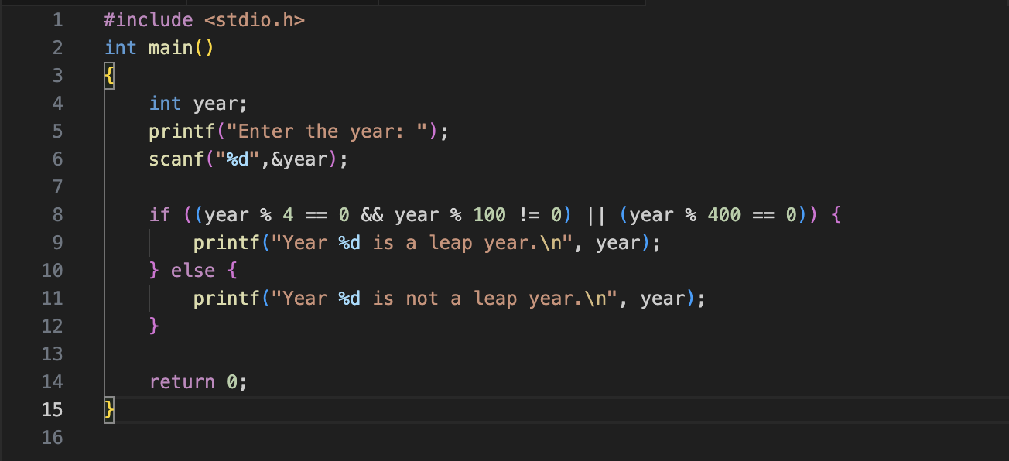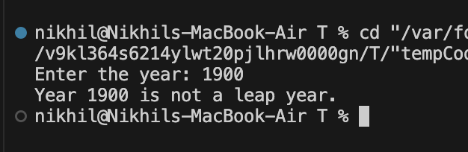

Refute Test Case: 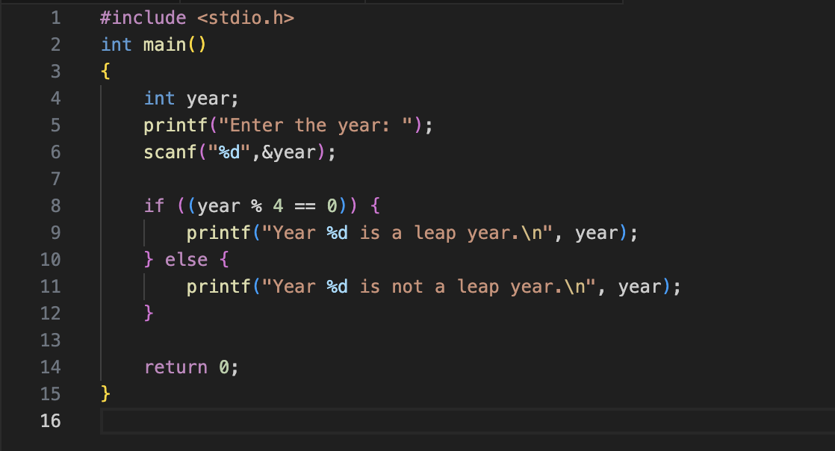

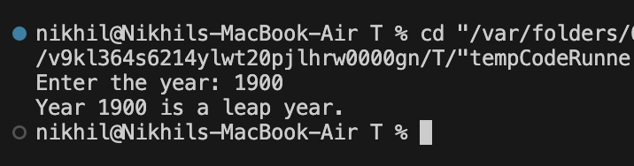

**Explanation of Failure:**

This code for determining a leap year is incorrect because it only checks if the year is divisible by 4. According to the rules of leap years, this check is incomplete. A year is considered a leap year if:

1. It is divisible by 4.
2. If it is divisible by 100, it must also be divisible by 400.

In simpler terms:

* If a year is divisible by 4 and not divisible by 100, it is a leap year.
* If a year is divisible by 100, it is only a leap year if it is also divisible by 400.

**Problem Statement II**

To write a program to check the radius of a circle

**Solution Code**

#include <stdio.h>

#define PI 3.14159

int main() {

int circumference;

int radius;

printf("Enter the circumference: ");

scanf("%d",&circumference);

radius = circumference / (2 * PI);

printf("The radius of the circle is: %.2d\n", radius);

return 0;

}

**Execution**

Correct Test Case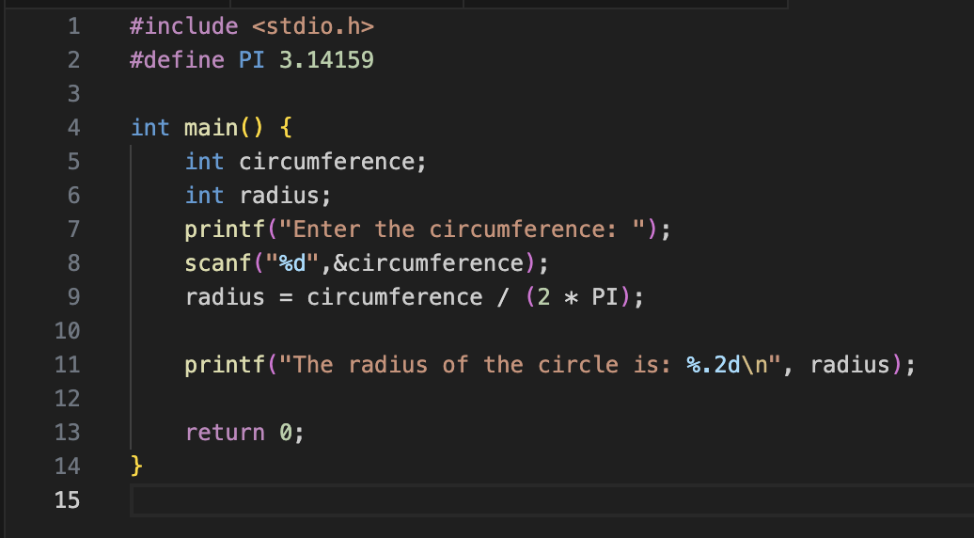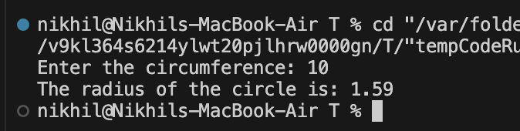

Refute Test Case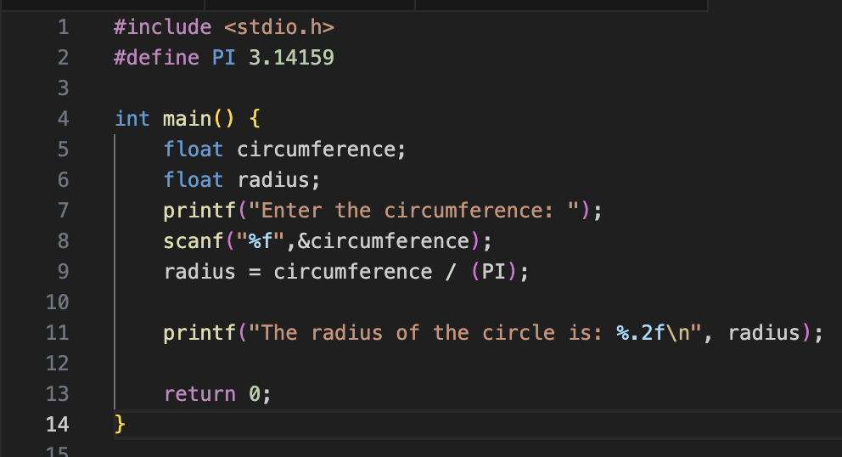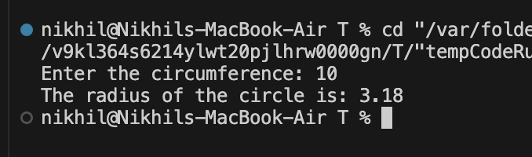

**Explanation of Failure**

The error in the code lies in the formula used to calculate the radius of a circle from its circumference. The formula used incorrectly divides the circumference by π (PI) instead of 2 × π.The error in the code lies in the formula used to calculate the radius of a circle from its circumference. The formula used incorrectly divides the circumference by π (PI) instead of 2 × π.

**THANK YOU..!!**